Chapter 5, Problem 56.

Using Fig. 5.83, design a problem to help other students better understand cascaded op amps.
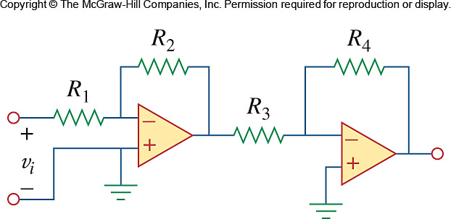

Figure 5.83
For Prob. 5.56.

